**USE CASE: Issue a deal**

Document History

Document Location

This is a snapshot of an on-line document. Paper copies are valid only on the day they are printed. Refer to the author if you are in any doubt about the currency of this document.

The source of the document will be found …

Revision History

|  |  |  |
| --- | --- | --- |
| Revision Number | Revision Date | Summary of Changes |
| 1.0 | 8/12/2013 | Initial document |
|  |  |  |
|  |  |  |
|  |  |  |
|  |  |  |

Approvals

This document requires following approval signature. Signed approval forms are filed in …

|  |  |
| --- | --- |
| **Name** | **Title** |
|  |  |
|  |  |
|  |  |
|  |  |

Distribution

This document has been distributed to:

|  |  |
| --- | --- |
| **Name** | **Title** |
|  |  |
|  |  |
|  |  |
|  |  |

Contents

1. Introduction 5

1.1 Purpose 5

1.2 References 5

1.3 Notation/Structure 5

2. Use Cases 6

2.1 Use Case Name: Start a free trial 6

2.1.1 Use Case Overview…. 6

# Introduction

Use Cases are detailed descriptions of how users and systems interact with an application. These descriptions include ideal paths with alternate paths and post conditions. This information assists the structure and interface design for the best possible experience for the site’s users. Additionally, the Use Cases are used by the QA team to ensure all objectives and requirements were met and fulfilled successfully.

A set of Use Cases can be created to describe the majority of user interactions with the application. The Use Case will ultimately drive the User Experience team in defining the interface. With a clear distinction between user and system interactions written in use case form the UI can be developed in more detail.

Each Use Case follows and tracks back to business requirements.

## Purpose

This document describes the Use Cases for the outlined system.

Use Cases are used to explore and communicate the likely actions of users and the system when interacting with the application. Development of Use Cases helps the design team understand the business requirements and how they can ultimately drive the design and user experience.

## References

This document is based on the following documents:

* Document Name

## Notation/Structure

Use Cases typically have the following sections:

1. Overviews
2. Preconditions
3. Triggers
4. Main Flows
5. Alternate Flows
6. Business Rules
7. Messages (system generated)

# Use Cases

## Use Case Name: Issue a deal

### Use Case Overview….

|  |  |  |
| --- | --- | --- |
| **Use Case ID** | **Issue a deal** | |
| **Use Case Overview** | When it's time for a prospective customer to receive the terms and conditions under which the seller will sell them the products and do business, a salesperson uses the system to select a master, describe the customer, and issue a copy of the master (a "deal") to the prospective customer. The system creates a named output file and issues it to the customer. The output file is a copy of the master plus some wrapper items like expiration date and document id.  This use case document describes issuing a deal to the prospective customer, including user provided information (forecast information for example) and system created information (expiration date and document ID number for example). | |
| **Precondition** | 1. Logged in 2. Adequate permissions to issue a deal | |
| **Trigger(s)** |  | |
|  | | |
| **B - Main Flow: Issue a deal** | | |
|  | B1 | Deals page  The deals page displays for the logged in user. The "Deals" tab in the primary navigation bar is highlighted and there is no secondary navigation pane. The page is titled, "Deals". Under the page title is an action button labeled "Add New". Underneath the "Add New" button is a content container. Within the container and at the top, is a picklist containing the entries of "All Deals", "Unexpired Deals", and "Expired Deals". By default, the picklist value is set to "Unexpired Deals". Adjacent to the picklist is a label of "View". Below the "View" picklist is a table consisting of 9 columns. The first column header is labeled "Deal Name", the second is labeled "Deal Owner", the third is labeled "Stage", the fourth is labeled "Date", the fifth is labeled "Elapsed Time (This Step), the sixth is labeled "Expires", the seventh is labeled "Turns", and the eighth is labeled "Elapsed Time (Total). Each column header can be used as the primary sort column by clicking on the column header. Clicking on the column header makes that column the sort column if it was not already the sort column. If the column header was already the sort column, then clicking on the header reverses the sort from ascending to descending. The default sort is the "Elapsed Time (This Step)" column with the sorted from longest amount of elapsed time to shortest elapsed time.  The records to be displayed in view are defined as follows: display the records that the user has permissions to view (if salesperson, they can only view their own deals; if sales manager they can all salespeople deals), and limited by the filter in the "View" picklist.  In the data rows, the user entered "Deal Name" is displayed under the "Deal Name" column header. If the user has sufficient permissions to audit a deal, then the Deal Name is formatted as hypertext. Under the "Deal Owner" column, the username and thumbnail picture of the user that issued the initial deal to the customer is displayed. Under the "`" column, a system created entry is displayed. The possible display entries are as follows: "Initially issued", "1st customer redline received", "1st redline response issued", "2nd customer redline received", "2nd customer redline response issued", "3rd customer redline received", etc.. Under the "Date" column, the date and time is displayed corresponding to the date and time that the step contained in the "Stage" column happened (the date/time of document upload, or the date/time of document issue). Under the "Elapsed Time (This Step)" column, a system calculated entry of the amount of elapsed time since the entry in the "Date" column is displayed in the format of "X days, Y hours). Under the column labeled, "Expires", a system calculated entry of the expiration date for the issued document is displayed based on the expiration days defined for the master document. If the stage is "..customer redline received", then the entry will be "N/A". Under the column labeled "Turns", a system calculated entry of the number of back and forths that have happened with the deal is displayed. For example, if the deal was issued, the first redline was received, and a first redline response was issued, this constitutes 3 turns and the number "3" is displayed in the "Turns" column. Under the "Elapsed Time (Total)" column, a system calculated entry of the amount of elapsed time since the initial issue is displayed in the format of "X days, Y hours".  Please see VR1 for a sample UI treatment.  If the user clicks through hypertext formatted Deal Name for a previously created deal, go to step A1.  The user clicks on the "Add New" action button and lands on the "Issue a New Deal" page. |
|  | B2 | "Issue a New Deal" page  The "Issue a New Deal" page displays. Under the Issue a New Deal page title, is a content container. At the top of the content container, text of "Customer Deal Information" is displayed. Beneath this text, there is an input field with a label of "Deal Name" to the left of it. Beneath this, there is an input field with a label of "Customer Name" to the left of it. Beneath this, there is an input field with a label of "Recipient Name" to the left of it. Beneath this, there is an input field with a label of "Recipient Email Address" to the left of it. Beneath this, there is a picklist with a label of "Master Document to Issue" to the left of it. Below the content container, two action buttons are displayed, the first with the label of "Next", and the second placed to the right of it with the label of "Cancel". See VR2 for a sample UI treatment.  "Deal Name, "Customer Name", and "Recipient Name" accept text information. "Recipient Email Address" accepts a string in the form of an email address. "Master Document to Issue" displays "--No Selection--" by default, but on click of drop down a list of all available friendly master document names are displayed (available means a master document that today's date falls after the "available after" and before the "available until" dates defined for that master document). The list displays the friendly master document names sorted in alphanumeric ascending order.  The validation criteria are as follows:  1. All fields must have entries  2. The "Recipient Email Address" must be in the form of an email address.  3. The "Master Document to Issue" cannot contain the default "--No Selection--" item.  If validation fails #1, reload the page and display red text "You must enter a value" under the field(s) that do not have an entry or entries.  If validation fails #2, reload the page and display red text "Enter a properly formed email address. For example john@company.com" under the Recipient Email Address entry box and label.  If validation fails #3, reload the page and display red text "You must make a selection" under the "Master Document to Issue" label and picklist.  If the user clicks "Cancel", return them to step B1.  User clicks on "Next" and after successful validation lands on "Review and Send" page. |
|  | B3 | The "Review and Send" page.  The "Review and Send" page displays. At the top of the page, the page title "Review and Send" displays. Below this is a content container which contains the text, "The following will be sent to the customer:" at the top left. Below this text is another content container. At the top of this container is a data entry box with the label "To" to the left of it. The data entry box contains the Recipient Name and Recipient Email Address defined in previous steps and is not editable. Beneath this is a data entry box with the label "From" to the left of it. The data entry box contains the sender name of "Contracts Administrator" as well as the email address of "donotreply@consentium.com", and is not editable. Beneath this is a data entry box with the label "Cc" to the left of it. The data entry box contains the salesperson's name (the person who is issuing the deal) and email address, and is not editable by the user. Beneath this is a data entry box with the label "Additional Cc" to the left of it. The "Additional Cc" data entry box has no entry by default but can be edited by the user. Underneath the "Additional Cc" data entry box and label is instructive text that says, "Enter email addresses separated by commas". Beneath this is a data entry box with the label "Bcc" to the left of it. The Bcc data entry box has no entry by default but can be edited by the user. Underneath the "Bcc" data entry box and label is instructive text that says, "Enter email addresses separated by commas" Beneath this is a data entry box with the label "Subject" adjacent to it. By default, the Subject field says "Emailing<Document File Name>, issued by <Company Name>. The Subject field can be edited by the user. Beneath this is the name of the file being emailed and the label of "Attachments" adjacent to it (not editable by the user). Below this is a content area where the user can write the email message content. By default this message content says, "The attached document has been issued for your review." This content can be edited. Beneath the content container, there are two action buttons. The first is labeled, "Send", and the second labeled "Cancel" is positioned to the right of it. See VR3 for a sample UI treatment.  If the user clicks Cancel, return them to Step B2.  If the user clicks "Send", do validation.  Validation is done as follows:  1. The "Subject" data entry box must not be empty  2. The "Content" data entry box must not be empty  If validation fails #1, display red text below the "Subject" entry field and label saying "A subject line is required".  If validation fails #2, display red text below the "Content" entry field saying "Message content is required".  Upon validation success, deliver the user to step 1 Deals page with the table refreshed and the banner message saying "Your message and document was sent". |
| **Post-**  **conditions** | * "Deal Name" storage folder created along with a subfolder, "<Friendly Master Document Name>Issued <dd/mm/yyyy>", and output file saved to this subfolder. * Output Doc created with a unique filename and stored according to storage mask (See Exhibit) * Output Doc created with unique doc id and expiration date on doc footer, all pages * Email sent with doc attached * Deal visible in the master list of deals, for the salesperson user plus those that have visibility across salespeople (sales manager for example) | |
|  | | |
|  | | |
| **A1** | **View Previously Issued Deal** | |
|  | A1.1 | User lands on "Deal Detail" page (see "receive a redline" use case, step B2 for a detailed definition of this page. VR4 below provides a sample UI treatment.  If the user clicks "Done", return the user to B1  If the user clicks "Audit", then take the user to the flows to be defined in "audit a review" use case.  If the user clicks "Status", then take the user to the flows to be defined in "check deal status" use case.  If the user clicks "View File", then spawn a new window and display a non-editable version of the issued or received file.  If the user clicks "Upload Customer Response Document", go to : use case receive a redline 08152013.docx", step B2  User clicks "Next" and lands on "View Issued Deal2" page. |
|  | A1.2 | "View Issued Deal2" page.  On this page the user can view the information that was originally entered on the "Review and Send" page when the deal was issued. The user can click action buttons of "Done" or "Back". See VR5 for a sample UI treatment.  User clicks "Done", return the user to A1.1 |
| **Post-**  **conditions** |  | |
|  | | |
| **A2** |  | |
|  | A2.1 |  |
|  | A2.2 |  |
| **Post-**  **conditions** |  | |
|  | | |
| **A3** |  | |
|  | A3.1 |  |
|  | A3.2 |  |
|  | A3.3 |  |
| **Post-**  **conditions** |  | |
| **A4** |  | |
|  | A4.1 |  |
| **Post-**  **conditions** |  | |
| **A5** |  | |
|  | A5.1 |  |
| **Post-**  **conditions** |  | |
|  | | |
| **Messages** | M1 |  |
|  |  |  |
|  |  |  |
|  |  |  |
|  |  |  |
|  |  |  |
|  |  |  |
|  |  |  |
|  |  |  |
|  |  |  |
|  | | |
| **BRs** | 1 |  |
|  | 2 |  |
|  | 3 |  |

Q&A

|  |  |  |  |
| --- | --- | --- | --- |
| **Question** | **Question Date** | **Answer** | **Answer Date** |
| What if the customer did not receive? Should there be a resend capability? Or should the salesperson reissue? | 8/12/13 | The salesperson goes through the issue process again. Yes, this does result in two deal records. | 8/12/13 |
| What if a salesperson quits while a deal is in progress? How does ownership of deals get transferred? | 8/12/13 | There needs to be a facility to xfer a deal to another user- because the sales guy quit or territories got rebalanced, whatever. Not in the scope of this use case, however. | 8/12/13 |
| What if the salesperson wants to view the master doc that they are thinking of sending (before they pick the doc) | 8/12/13 | Would be great but it's not required for the initial system. | 8/12/13 |
|  |  |  |  |
|  |  |  |  |
|  |  |  |  |
|  |  |  |  |
|  |  |  |  |
|  |  |  |  |
|  |  |  |  |

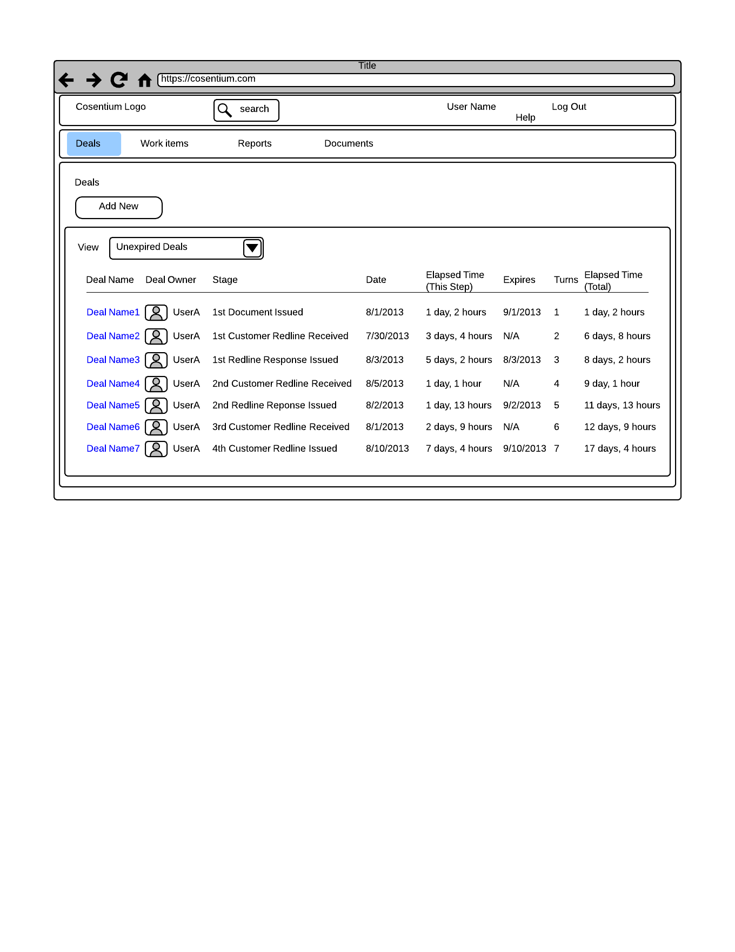

VR1: "Deals - New Page -1.png"

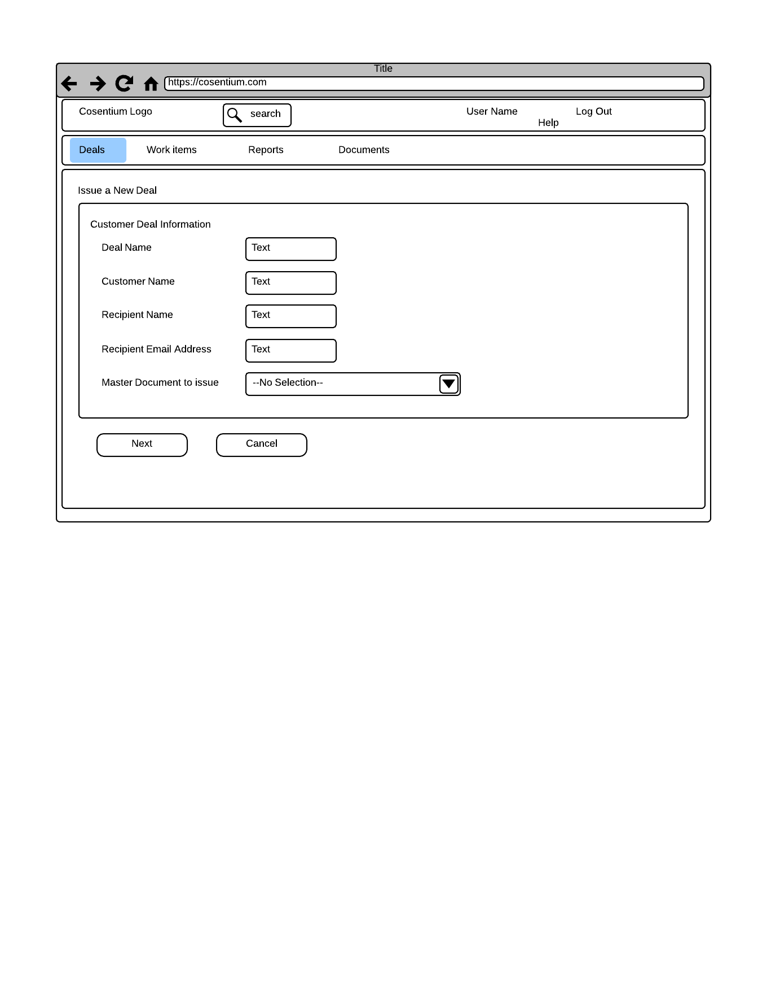

VR2: "Issue a New Deal - New Page-2.png"

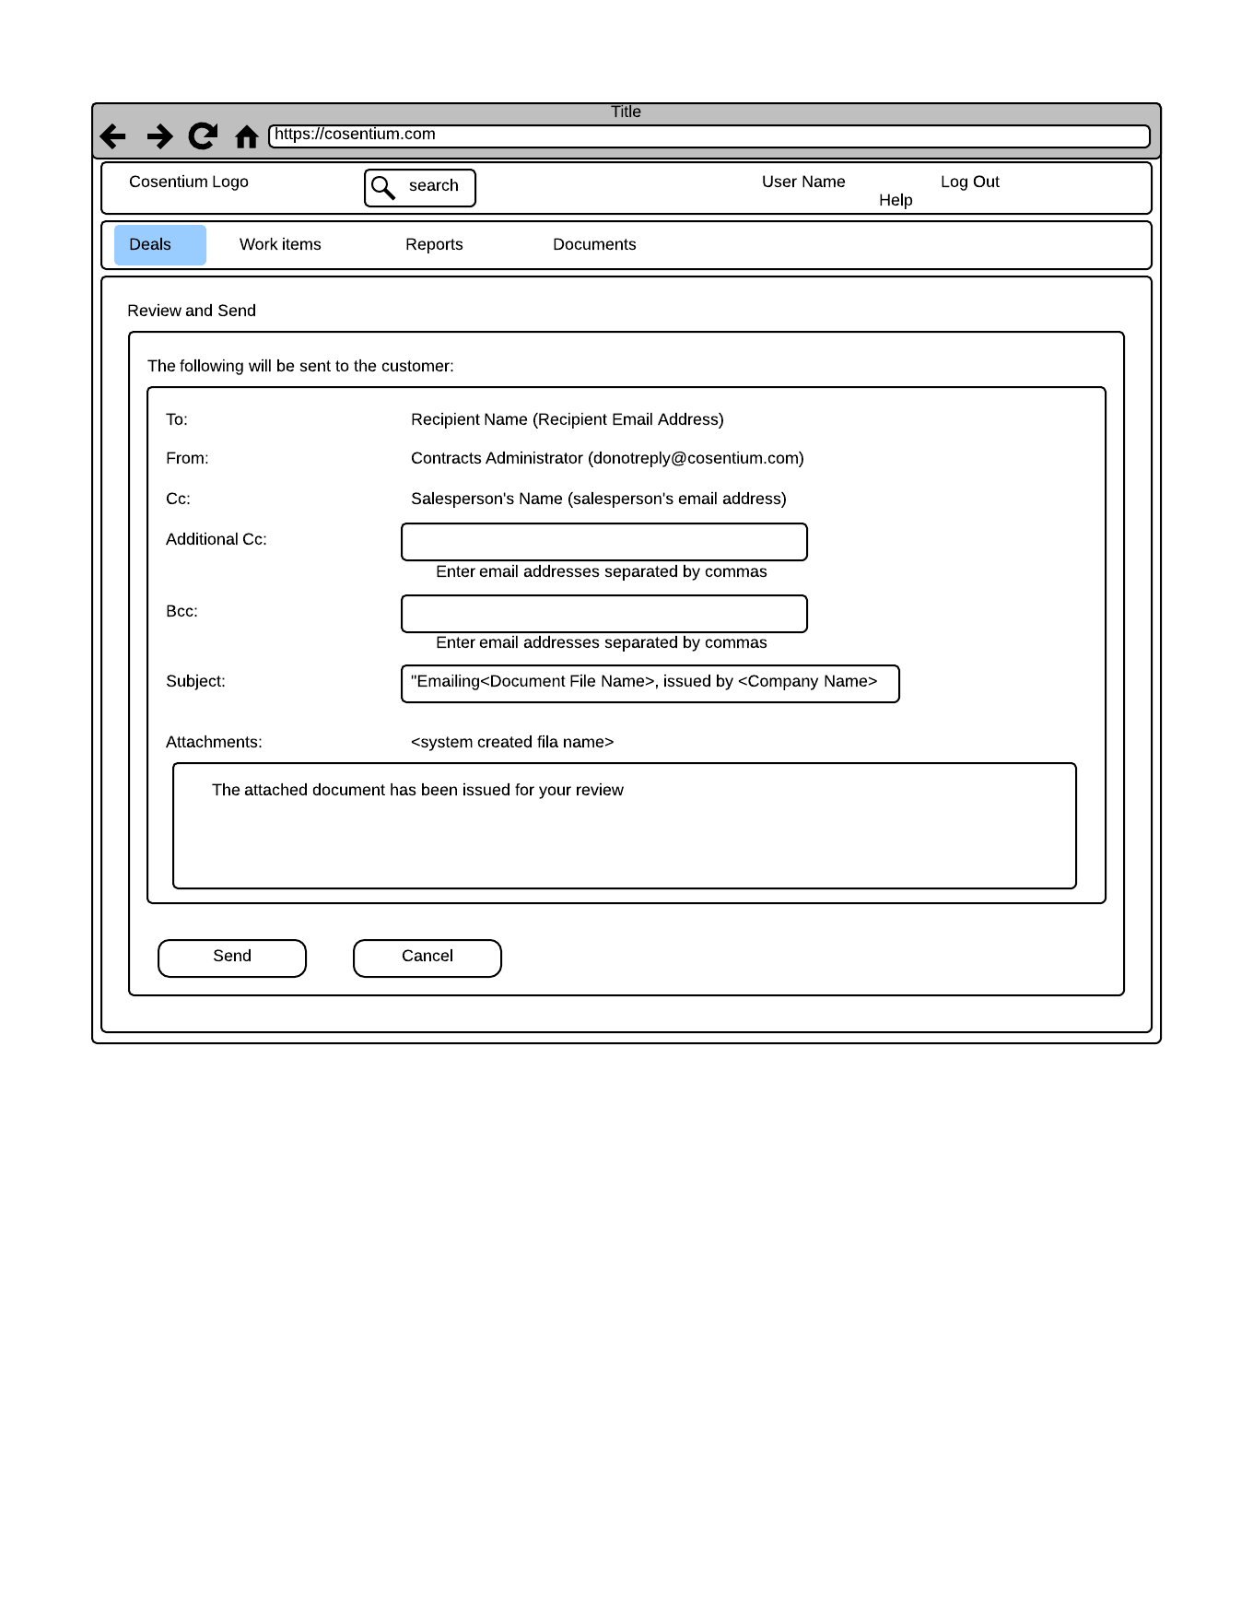

VR3: "Review and Send - New Page.png"

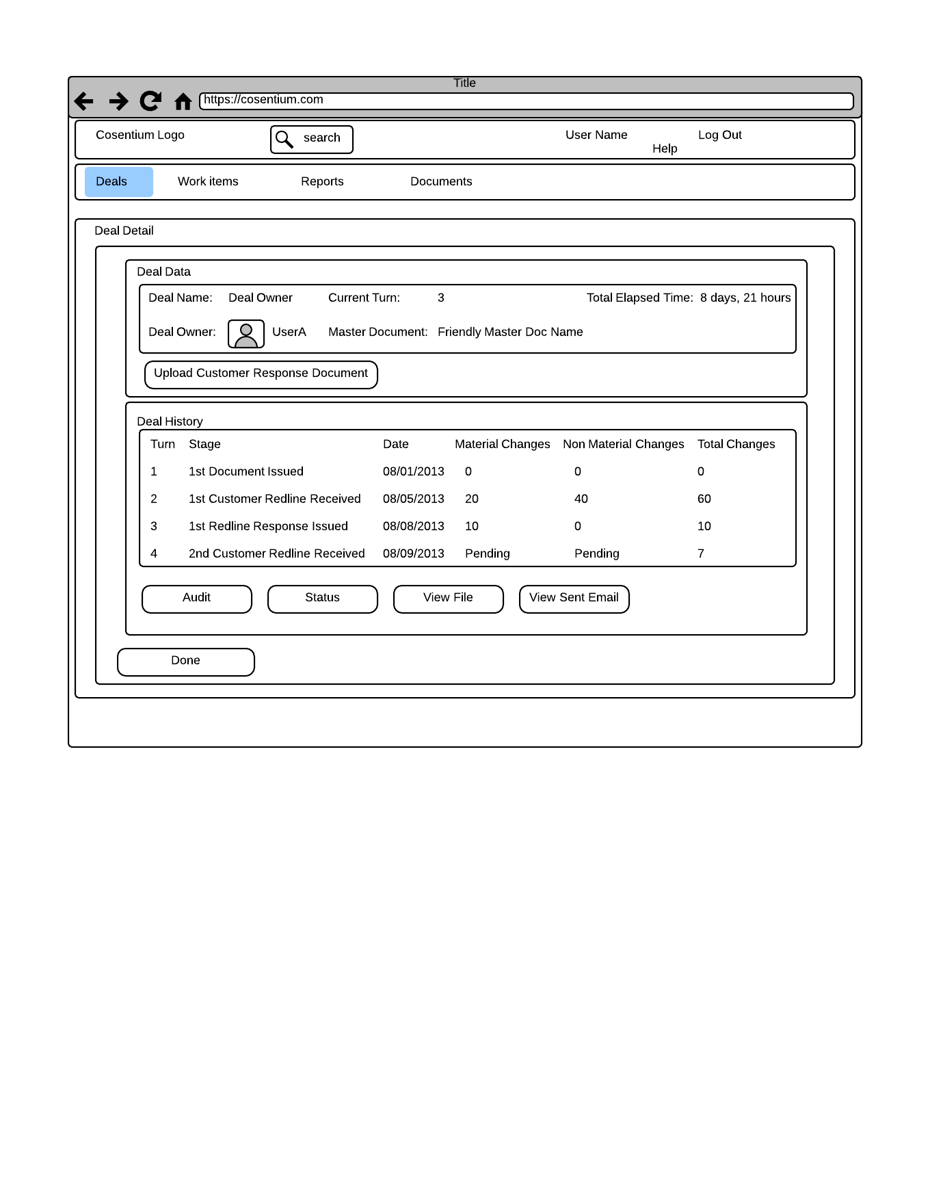

VR4: "Deal Detail - New Page.png"

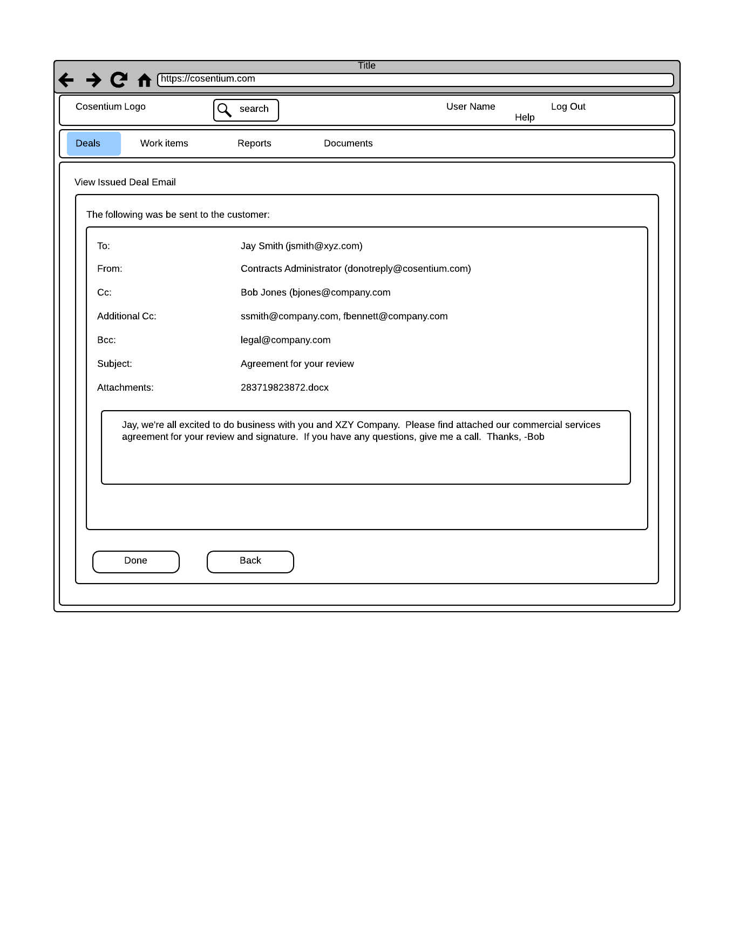

VR5: "View Issued Deal - New Page.png"

Exhibit A: Output File Storage Hierarchy

Customer Folder

--> "Deal Name" Folder

--> "<Friendly Master Document Name>Issued <dd/mm/yyyy>" Sub Folder

-->"<Friendly Master Document Name>1st Redline Received<dd/mm/yyyy>" Sub Folder

-->"<Friendly Master Document Name>1st Redline Response Issued<dd/mm/yyyy>" Sub Folder

-->"<Friendly Master Document Name>2nd Redline Received<dd/mm/yyyy>" Sub Folder

-->"<Friendly Master Document Name>2nd Redline Response Issued<dd/mm/yyyy>' Sub Folder